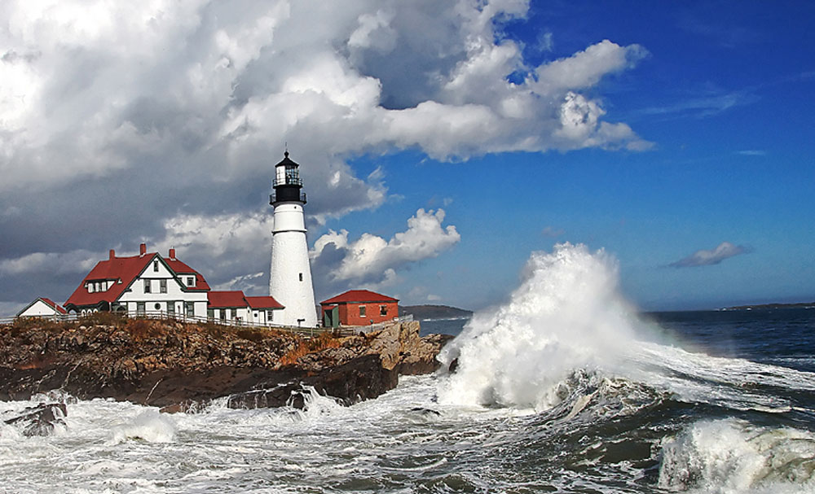
Portland Head Light coastline - Photo by: Richard Morin
CMSNE 2025 Maine Extension Conference
Navigating Changing Times…. Updates and Insights for Case Managers
Saturday, September 27, 2025 8:00 AM – 4:35 PM
Elks Lodge, Portland, ME

Dear Prospective Conference Sponsor:

We are pleased to announce that on Saturday, September 27, 2025, the CMSNE Maine Extension will host, Navigating Changing Times…. Updates and Insights for Case Managers at the beautiful Elks Lodge in Portland, ME. This year’s conference will provide content for all case managers by sharing a current understanding of important topics that impact case management practice; ranging from Rural Health, Federal and State Legislative changes, patient clinical complexity, and patient needs in the context of scarcity.

For over 37 years, CMSNE has provided exceptional, innovative, and quality educational offerings that meet the needs of healthcare professionals in the New England region. We have been recognized as one of the premiere chapters of the Case Management Society of America. To continue with this goal, we are reaching out to you for your support and participation.

Your contribution will enable us to offer member benefits at a minimal cost and provide attendees with an opportunity to enhance their educational resources. With over 330 members in the New England Region, we hope you will find the networking and marketing opportunities invaluable. CMSNE offers a variety of sponsorship opportunities to meet your specific needs, from in-person or virtual exhibitions to sponsoring conference CEUs, giveaways, or breaks.

We are eagerly looking forward to your potential sponsorship of this highly anticipated annual educational event. Please note that space is limited to 18 onsite exhibitors. We have attached the agreement form for your review and completion if you are interested. We hope to welcome you to our event!

Sincerely yours,

CMSNE Maine Extension Conference Committee

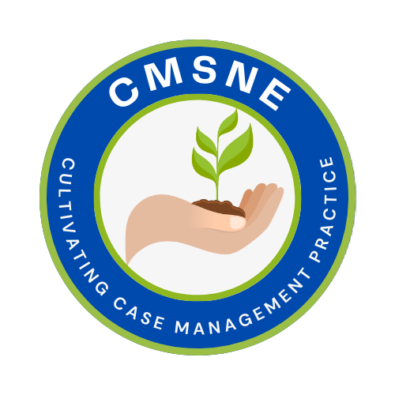 | CMSNE  74 Buckboard Rd., Duxbury, MA 02332  603-329-7481 CMSNE@comcast.net www.CMSNE.org  TIN: 04-3159207

CMSNE MAINE EXTENSION CONFERENCE – Exhibitor/Sponsorship Agreement
PLEASE COMPLETE THIS AGREEMENT AND RETURN TO CMSNE OFFICE
TO SECURE YOUR PARTICIPATION

PLEASE INDICATE YOUR PARTICIPATION PREFERENCE

All sponsors/exhibitors will be recognized for their support in the following ways:
on the CMSNE website, in all conference marketing materials, in the attendee conference
sponsor/exhibitor listing, as well as on a rotating slide deck displayed during conference breaks.

 | $500 Conference Continuing Education Sponsorship includes your company name/logo as sponsor of conference continuing education credits and a full color marketing insertion in tote bag recognizing your support - 1 |  | $1000 Conference tote bag sponsorship includes your company name/logo on a tote bag and a full color  marketing insertion in tote bag recognizing your support - 2
 | $500 Morning or afternoon break sponsorship includes signage at the break area and a full color  marketing insertion in tote bag recognizing your support - 1 |  | *$1000 Conference Water Bottle sponsorship includes your company name/logo on the bottle and a full color marketing insertion in tote bag recognizing your support - 1
 | $500 Unrestricted grant includes a full color  marketing insertion in tote bag recognizing your support and an attendee listing electronically. |  | *$1000 Thermal lunch bag sponsorship includes your company name/logo on the bag and a full color marketing insertion in tote bag recognizing your support - 1
 | $950 Exhibit Space includes a table top exhibit area, 1 full conference registration for your company representative and an attendee listing onsite and electronically - 18 |  | $250 Virtual Advertisement a full color marketing insertion in tote bag recognizing your support. Consideration will also be given to exhibitors interested in sharing company give away item, i.e. tote bag, water bottle, hand sanitizer, etc. (Vendors responsibility to assure shipping costs to CMSNE.)
*CMSNE will consider sponsor providing their own tote bag, water bottle or thermal lunch bag.

PLEASE COMPLETE – THIS INFORMATION WILL BE INCLUDED IN YOUR CONFERENCE LISTING

Company/Organization Name: _________________________________________________________________________
Mailing Address: _____________________________________________________________________________________
City/State/Zip Code: __________________________________________________________________________________
Business Phone: _________________________________ Mobile: ___________________________________________
Email: __________________________________________ Website:__________________________________________
Designated Company Contact:__________________________________________________________________________
Title: ______________________________________________________________________________________________
Please provide a brief description of services and/or products, not to exceed 50 words. This will appear in the final conference program. Please include as an attachment or at the end of this agreement. Please forward a jpeg or png file of your company logo to the chapter office at CMSNE@comcast.net for inclusion in conference recognition materials.

One Full Conference Registration per table will be issued for personnel staffing your exhibit. Please list your exhibiting representative below. Names must be received before September 19, 2025. Additional registrations can be purchased at a member rate – these individuals should register directly through the CMSNE conference registration link.

Company Representative: □ Same as above or____ _______________________________________________________
Title: ______________________________________________________________________________________________
Company/Organization Name: _________________________________________________________________________
Mailing Address: ____________________________________________________________________________________
City/State/Zip Code: __________________________________________________________________________________
Direct Phone: _________________________________ Email: ___________________________________________
Does your company representative require CEU credits? □Yes □ No If yes what certification: □RN □SW □ CCM
Does your company anticipate electrical access? □ Yes □ No

IN ORDER TO SECURE YOUR SPONSORSHIP YOUR COMPLETED AGREEMENT MUST BE RECEIVED BY THE CMSNE OFFICE AND PAYMENT METHOD DETERMINED. COMPLETED AGREEMENT CAN BE EMAILED DIRECTLY TO CMSNE@COMCAST.NET

PAYMENT METHOD - CREDIT CARD, ACH TRANSFER, CHECK

- CREDIT CARD – Please contact the CMSNE office with credit card information – for security reasons do not email credit card information
Name on Card:
Card Type: □Visa □ Mastercard □ American Express
Card Number:
Exp. Date: ___________________________ Security Code: _________________________________________

- ACH TRANSFER – Please contact the CMSNE office to coordinate this payment.

- CHECK – Make checks payable to CMSNE. Mail to 74 Buckboard Rd., Duxbury, MA 02332

For sponsors requiring a current CMSNE W9 it can be downloaded at this link:
https://www.cmsne.org/wp-content/uploads/2025/06/2025-CMSNE-W-9.pdf

PLEASE UTILIZE THIS SPACE FOR COMPANY/ORGANIZATION’S DESCRIPTION OR ADDITIONAL COMMENTS.

CMSNE Maine Extension Conference
Navigating Changing Times….
Updates and Insights for Case Managers
Saturday, September 27, 2025 8:00 AM – 4:35 PM
Elks Lodge, Portland, ME
Portland Head Light coastline - Photo by: Richard Morin
Conference Purpose Statement:
This conference will provide content for all case managers by sharing a current understanding of important topics that impact case management practice; ranging from Rural Health, Federal and State Legislative changes, patient clinical complexity, and patient needs in the context of scarcity.

Overall Conference Objectives:
Upon completion of this conference the attendees will be able to:
- Cite the challenges of rurality in healthcare.
- Discuss the national and local legislative decisions impacting our healthcare system and their affect on the New England states.
- Summarize the power of palliative care in helping patients and families navigate care choices
- Describe Regenerative Medicine and list the various treatment approaches.
- Summarize the experience of scarcity and how it changes your point of view and your clients’ lives.
6.5 RN, SW and CCM Credits
Registration: EARLY BIRD SAVE $10 until 9/5/25
$130 CMSNE member, $175 non-member,
AFTER 9/5/25 $140 CMSNE member, $185 non-member
Registration includes continental breakfast, lunch and coffee breaks

